Linux Fundamentals & Intermediate Assignment

Page 1: Introduction to Linux

Task 1: Understanding Linux

- Write a short paragraph on what Linux is.

Linux is an open-source, Unix-like operating system kernel that serves as the core of various operating systems known as Linux distributions. It is renowned for its stability, security, and flexibility, making it a popular choice for servers, desktops, embedded systems, and even supercomputers. Developed initially by Linus Torvalds in 1991, Linux has since become the foundation of many modern computing systems and is widely supported by a global community of developers.

- Mention at least 3 Linux distributions and their use cases.

**Ubuntu**  
– **Use Case**: Ideal for beginners and general-purpose desktop use.  
– **Why**: User-friendly interface, large software repository, and strong community support.

**CentOS / AlmaLinux (RHEL-based)**  
– **Use Case**: Enterprise servers and production environments.  
– **Why**: Long-term support, stability, and compatibility with Red Hat-based systems.

**Kali Linux**  
– **Use Case**: Penetration testing and cybersecurity tasks.  
– **Why**: Comes pre-installed with a wide range of security tools for ethical hacking.

Task 2: System Navigation Basics

- Commands: pwd, ls, cd, clear, echo, whoami

Exercise:

1. Navigate to the home directory.

2. List all hidden files.

3. Create a file called intro.txt and write a line into it.

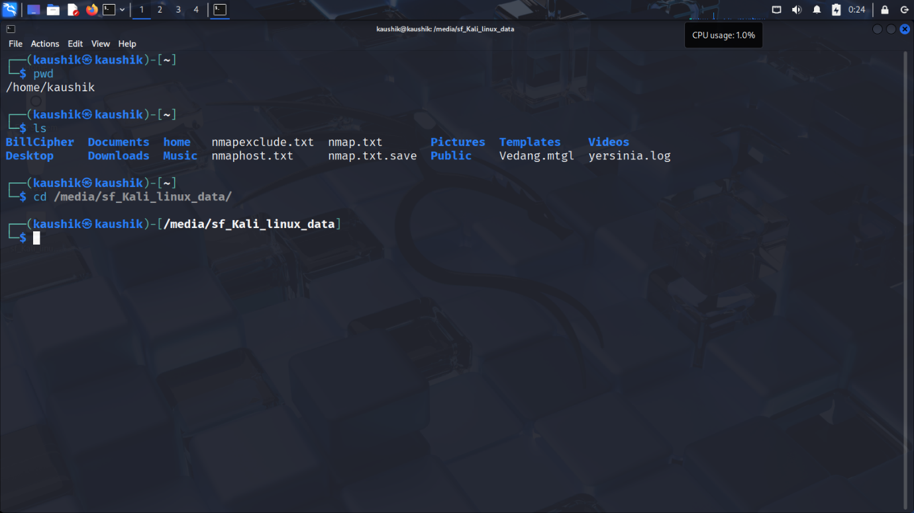

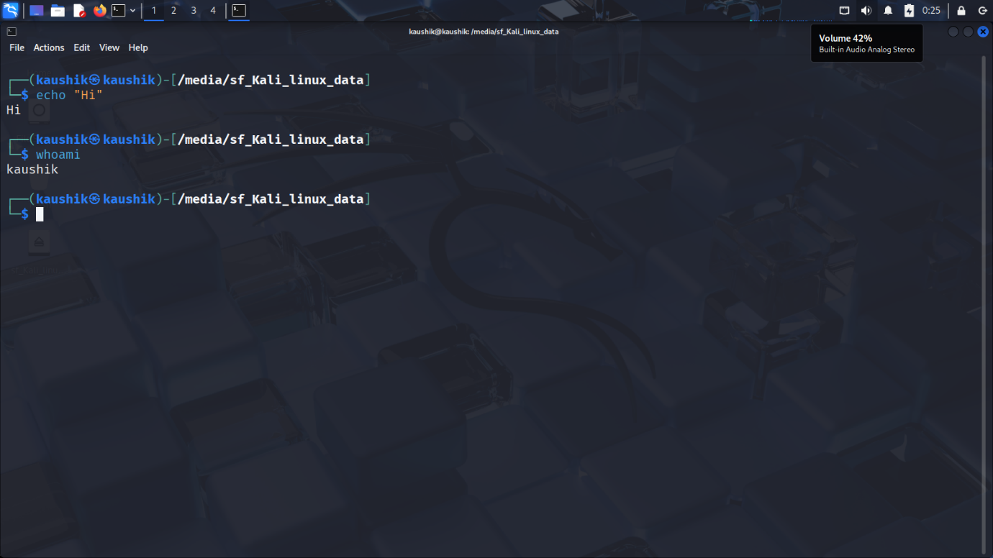

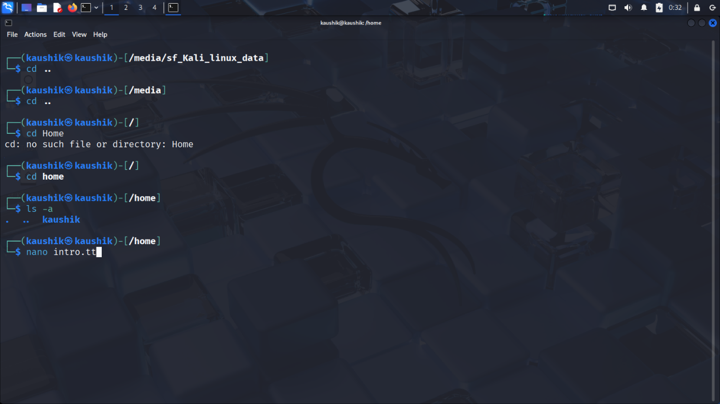

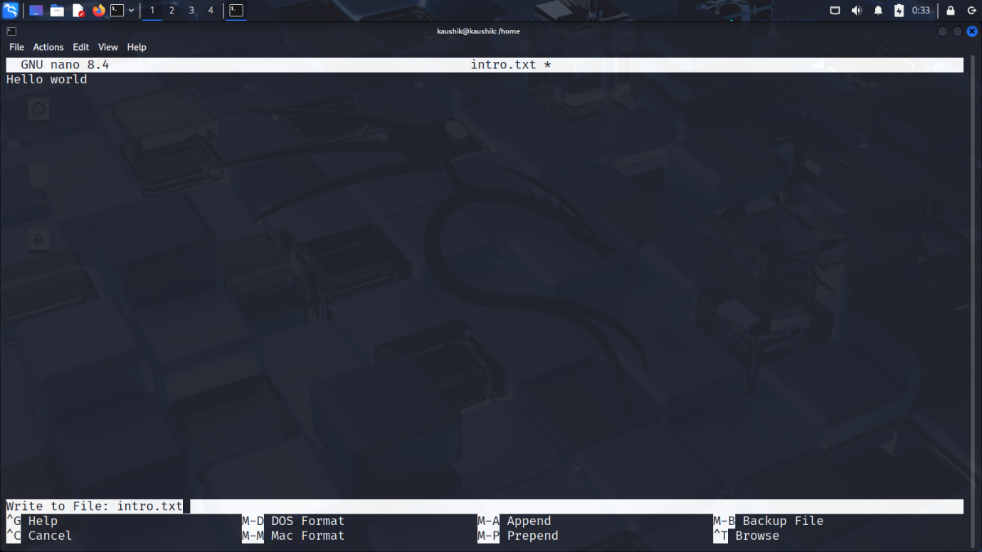

Page 2: File and Directory Operations

Task 1: File Management

- Commands: touch, mkdir, rm, rmdir, mv, cp, cat, nano, less

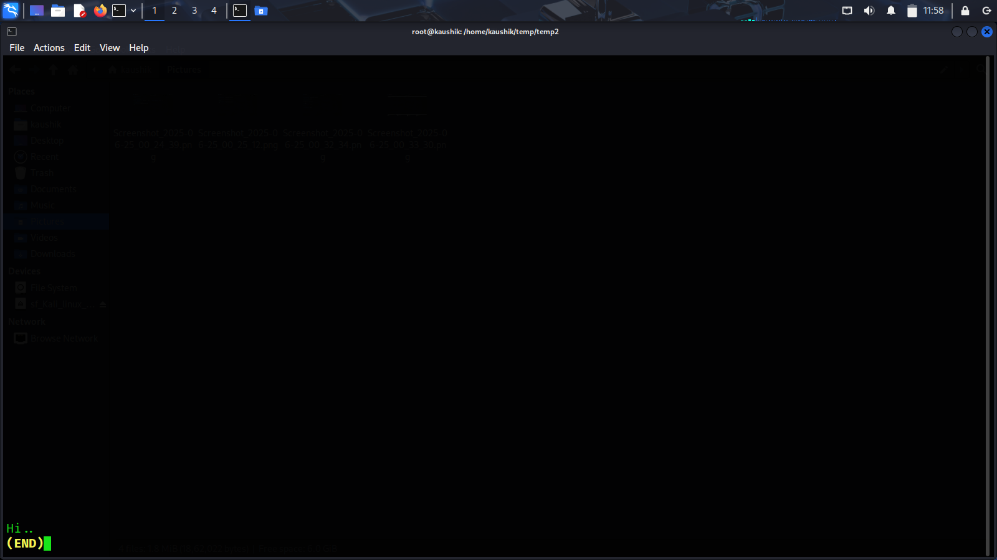

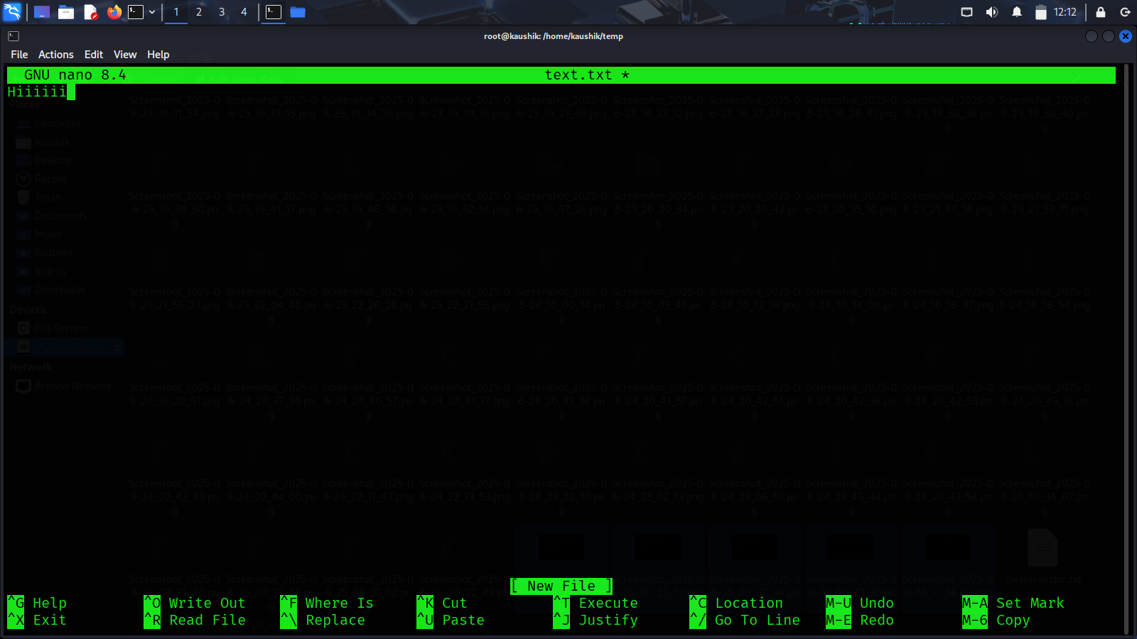

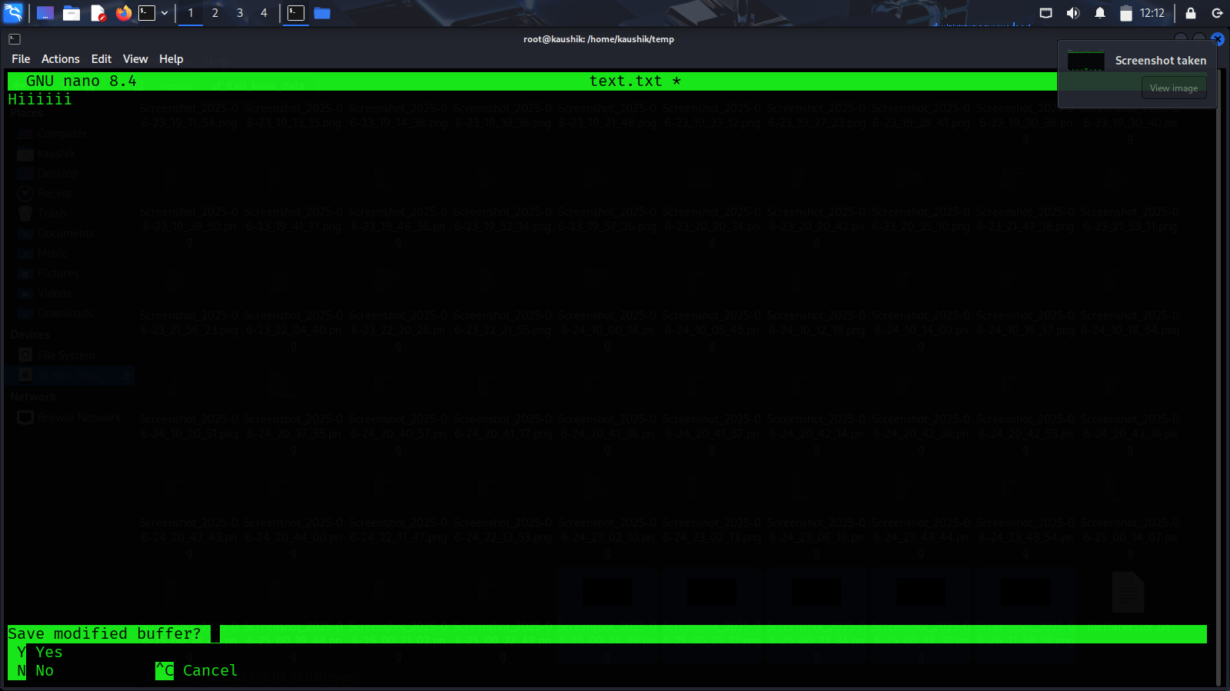

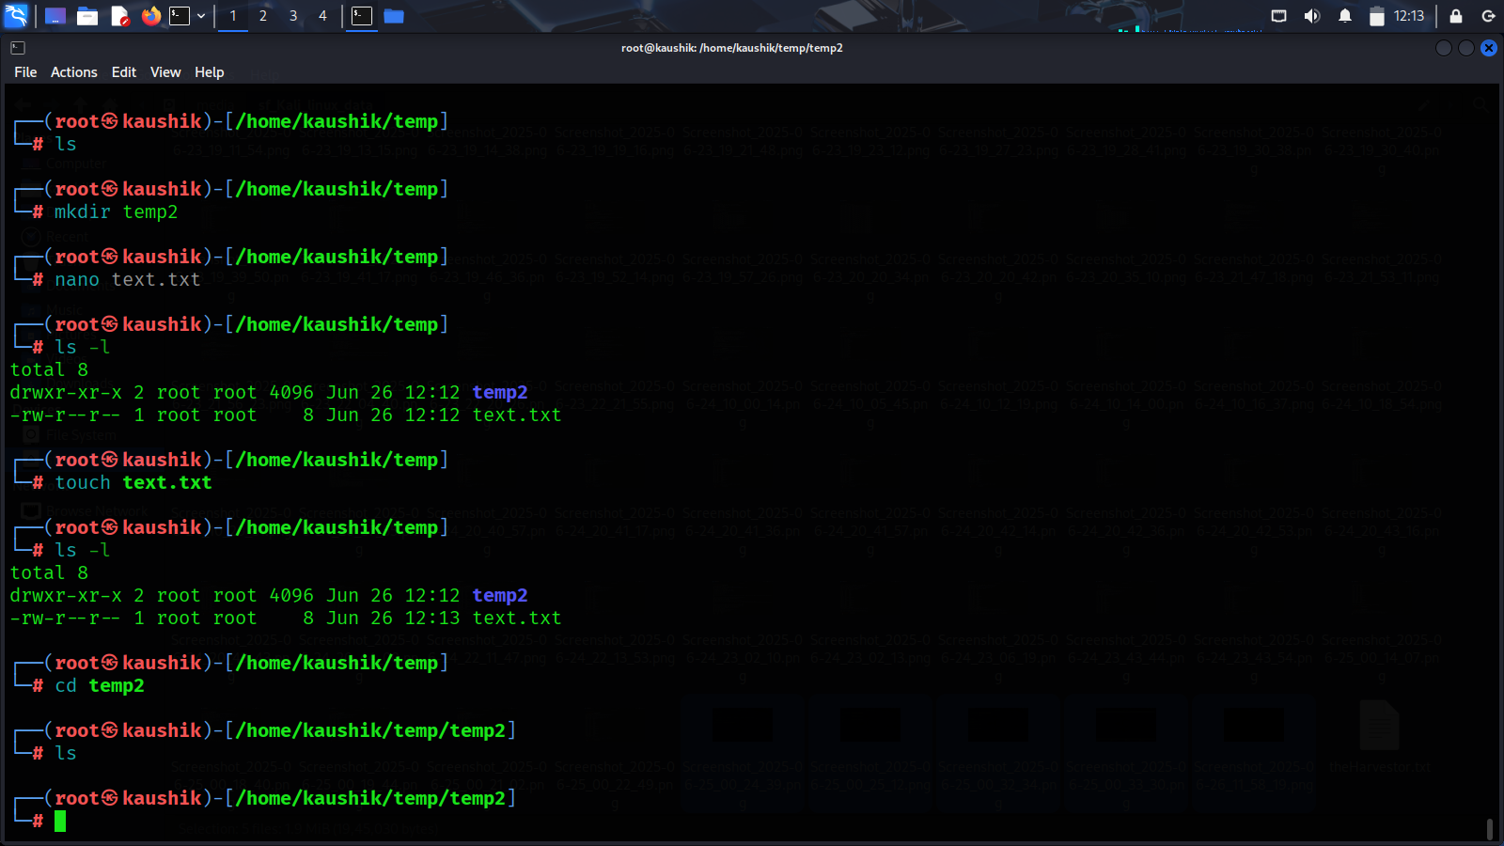

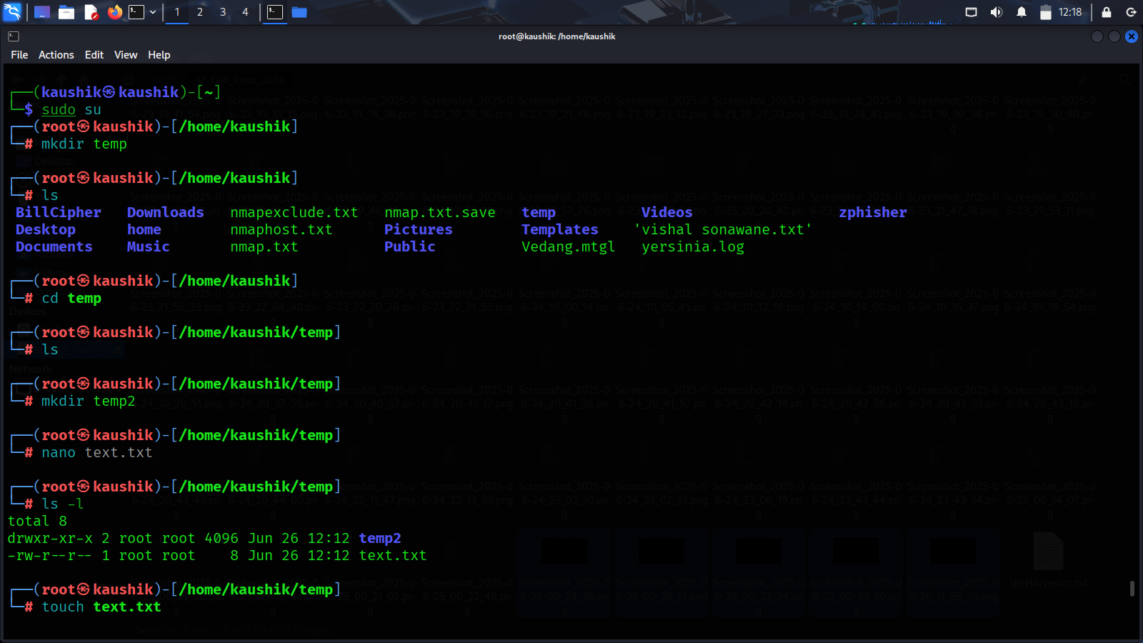

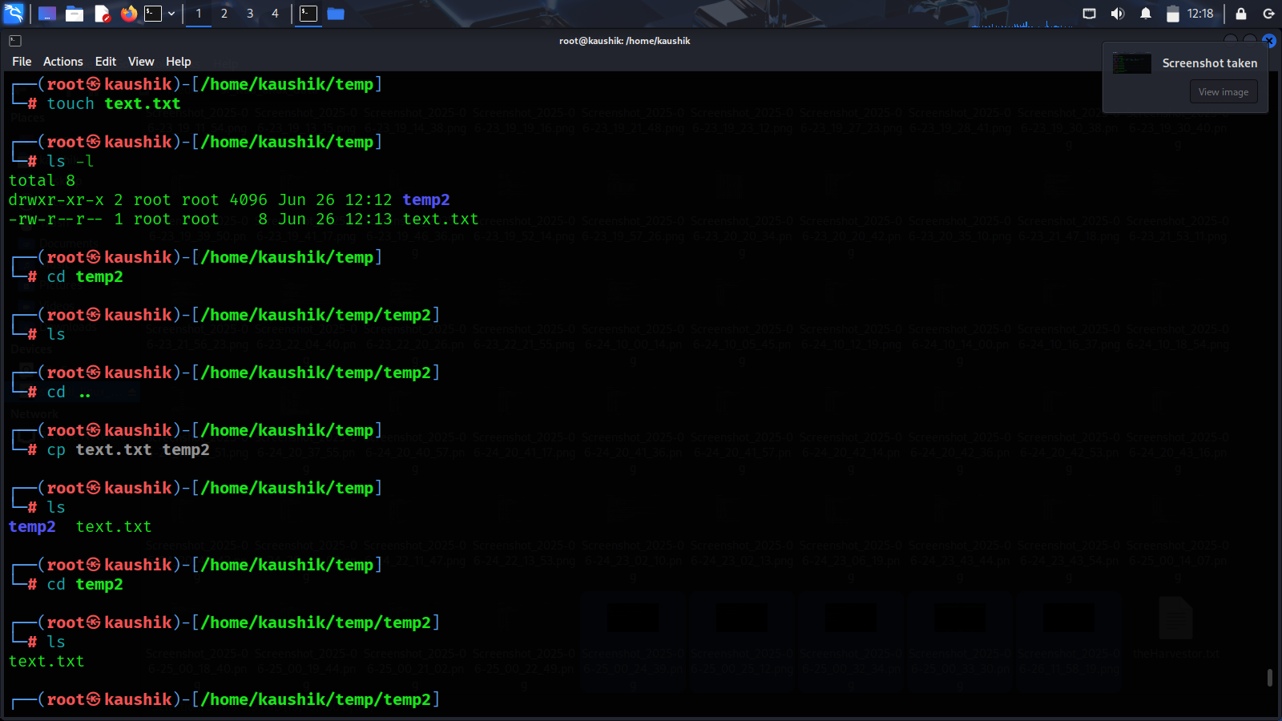

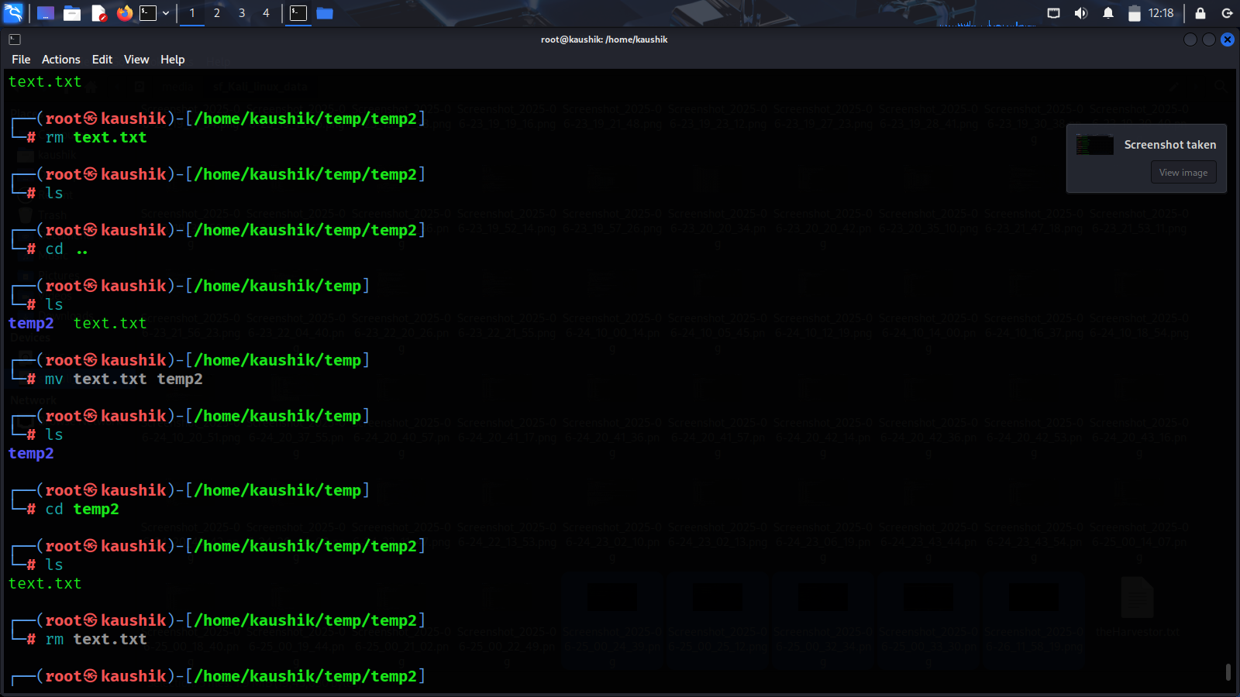

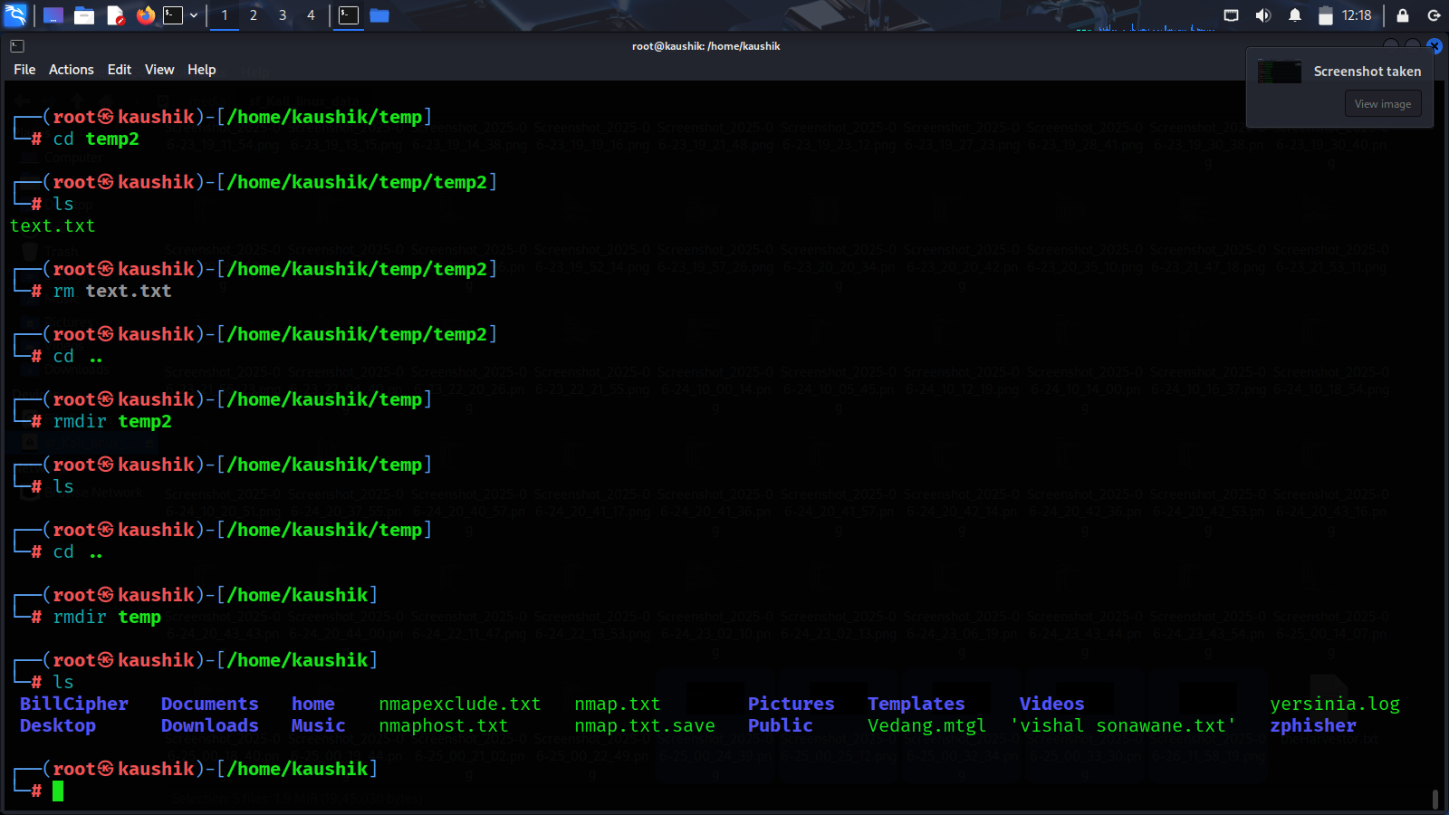

Task 2: Exercises

- Create a directory linux_practice.

- Inside it, create a file info.md, add some content, and then copy it as info_backup.md.

- Move the info.md to a folder archives.

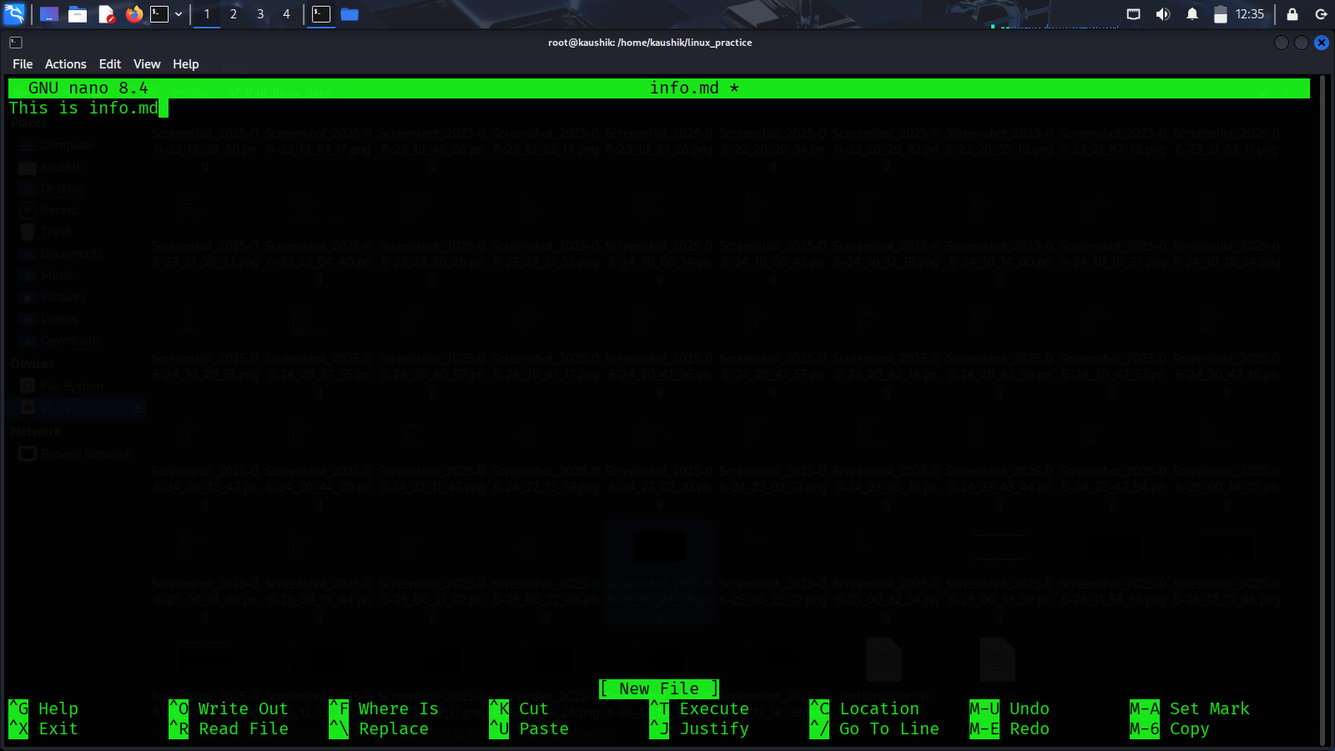

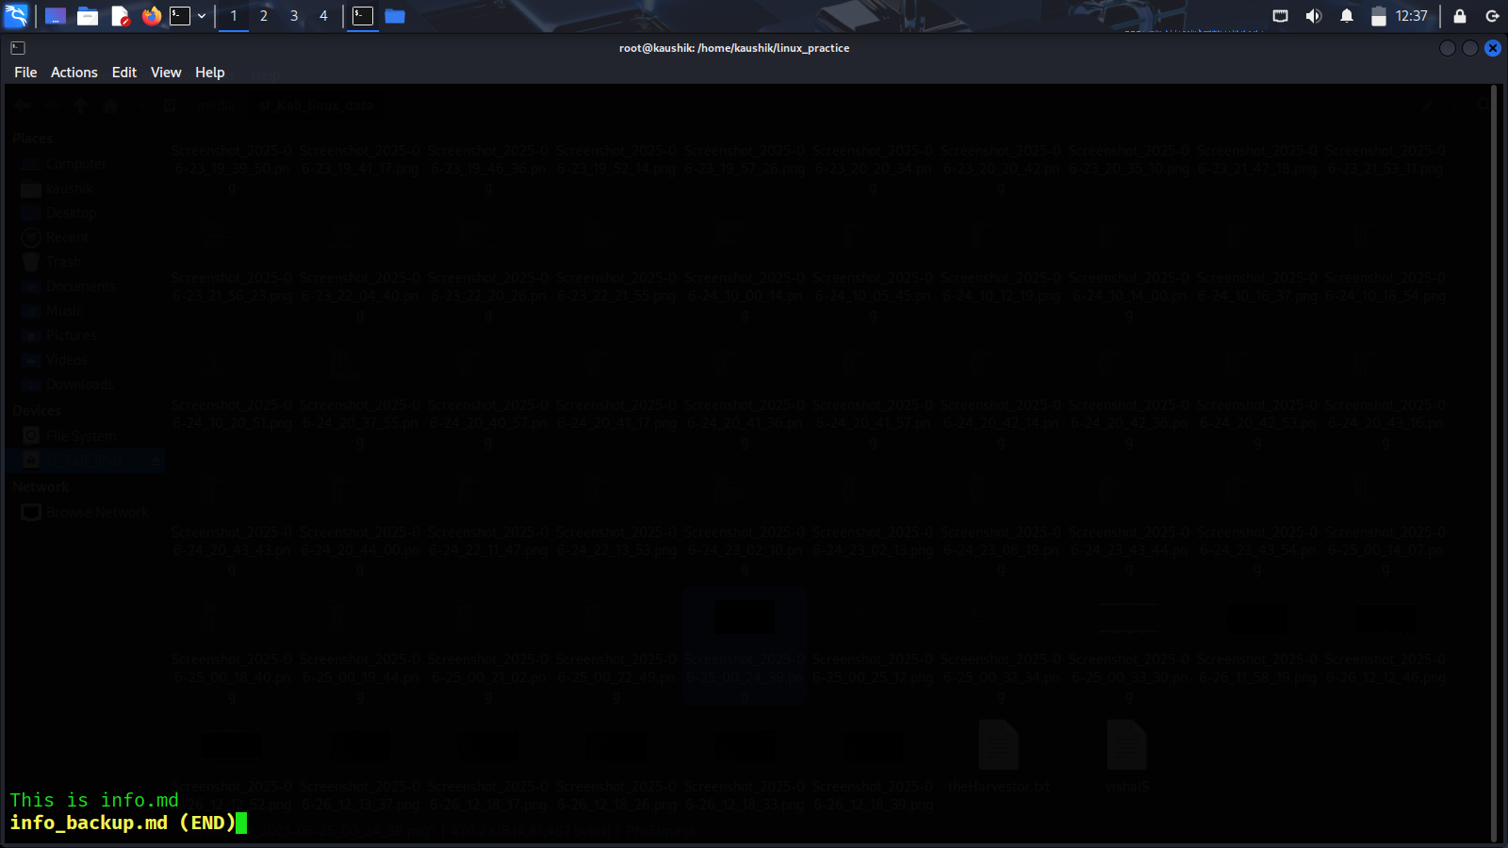

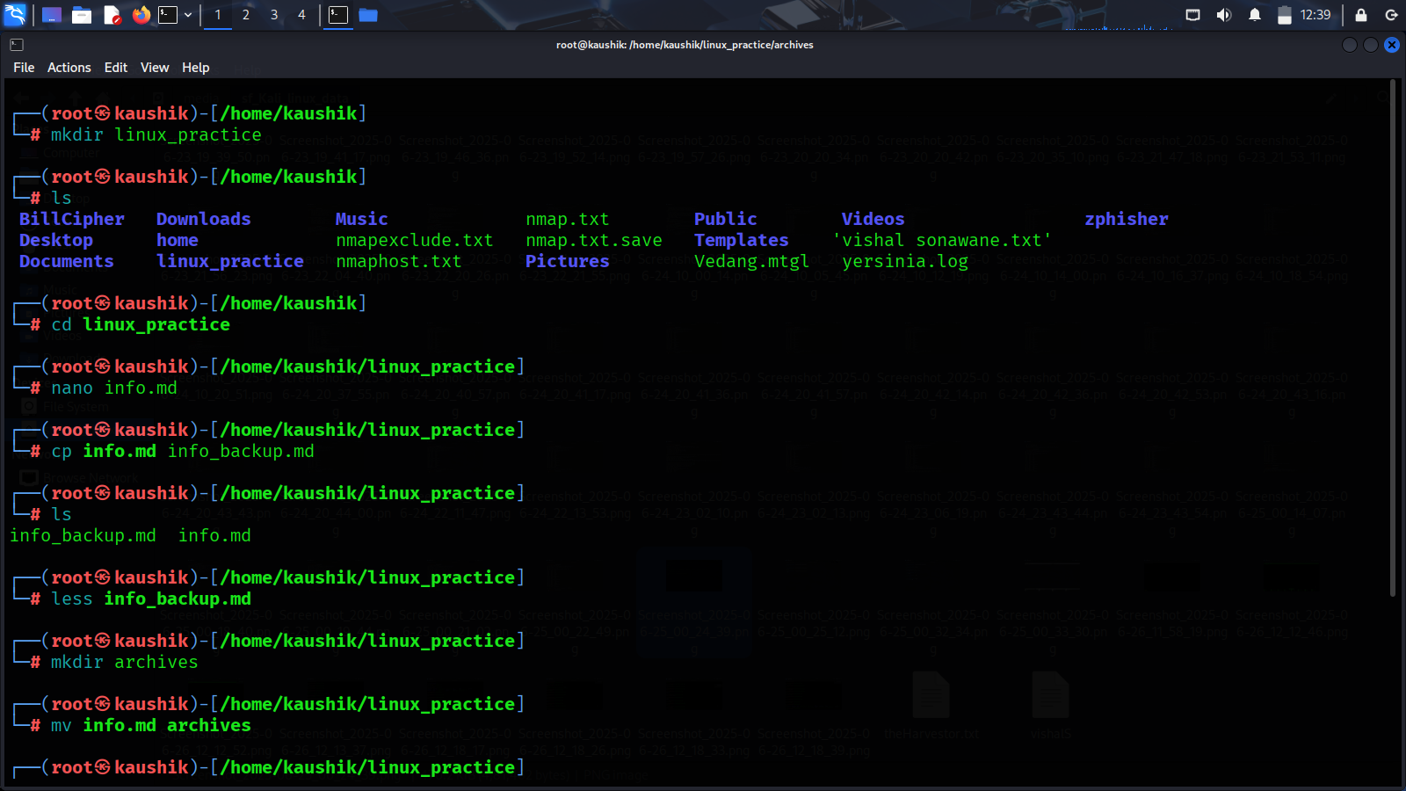

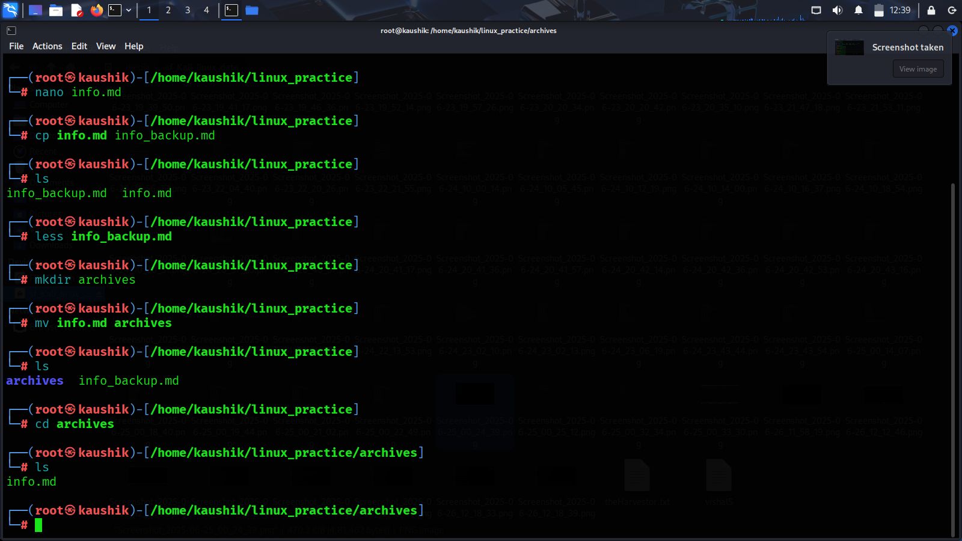

Page 3: File Permissions

Task 1: Understanding File Permissions

- Explain file permission notations (e.g., -rwxr-xr--).

In Linux, file permissions determine **who can read, write, or execute** a file. These are displayed using symbolic notation when you run the ls -l command.

- Commands: chmod, chown, ls -l

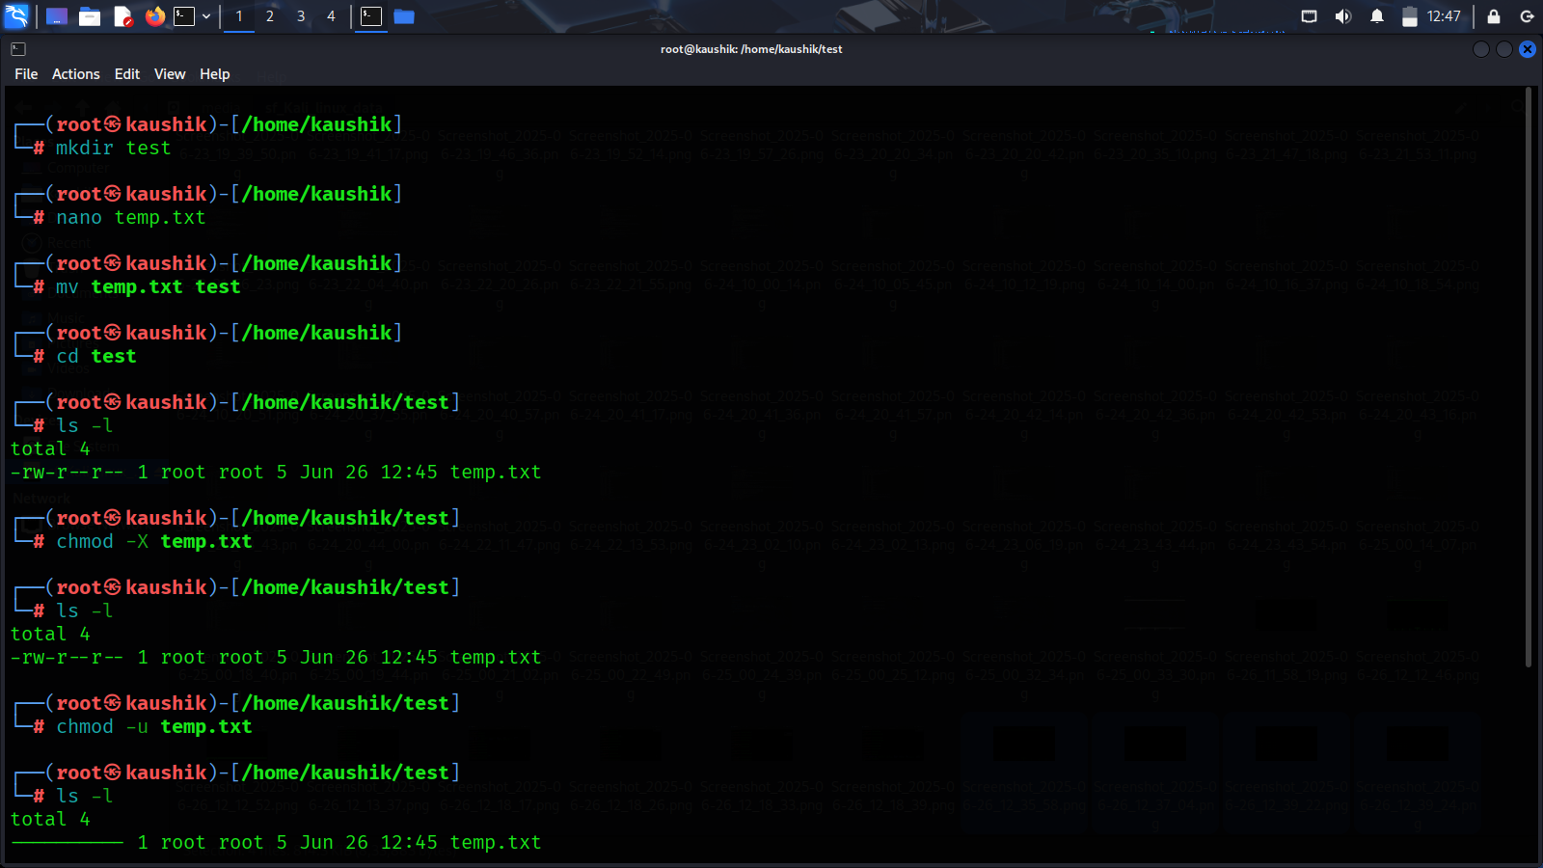

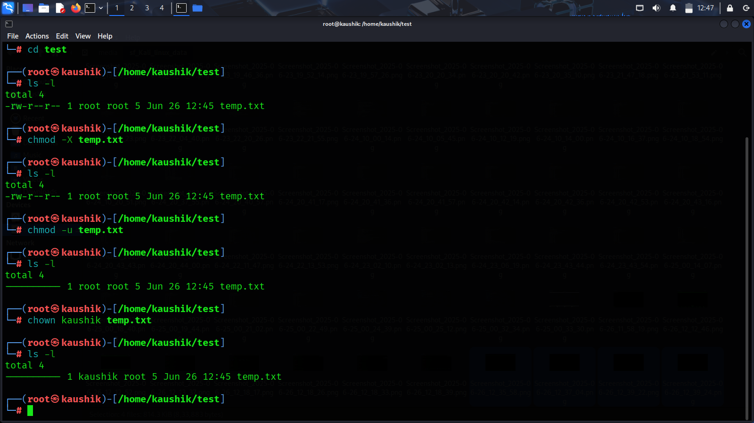

Task 2: Exercises

- Create a script file test.sh and give it execute permission.

- Change the ownership of a file to a different user (use sudo if needed)

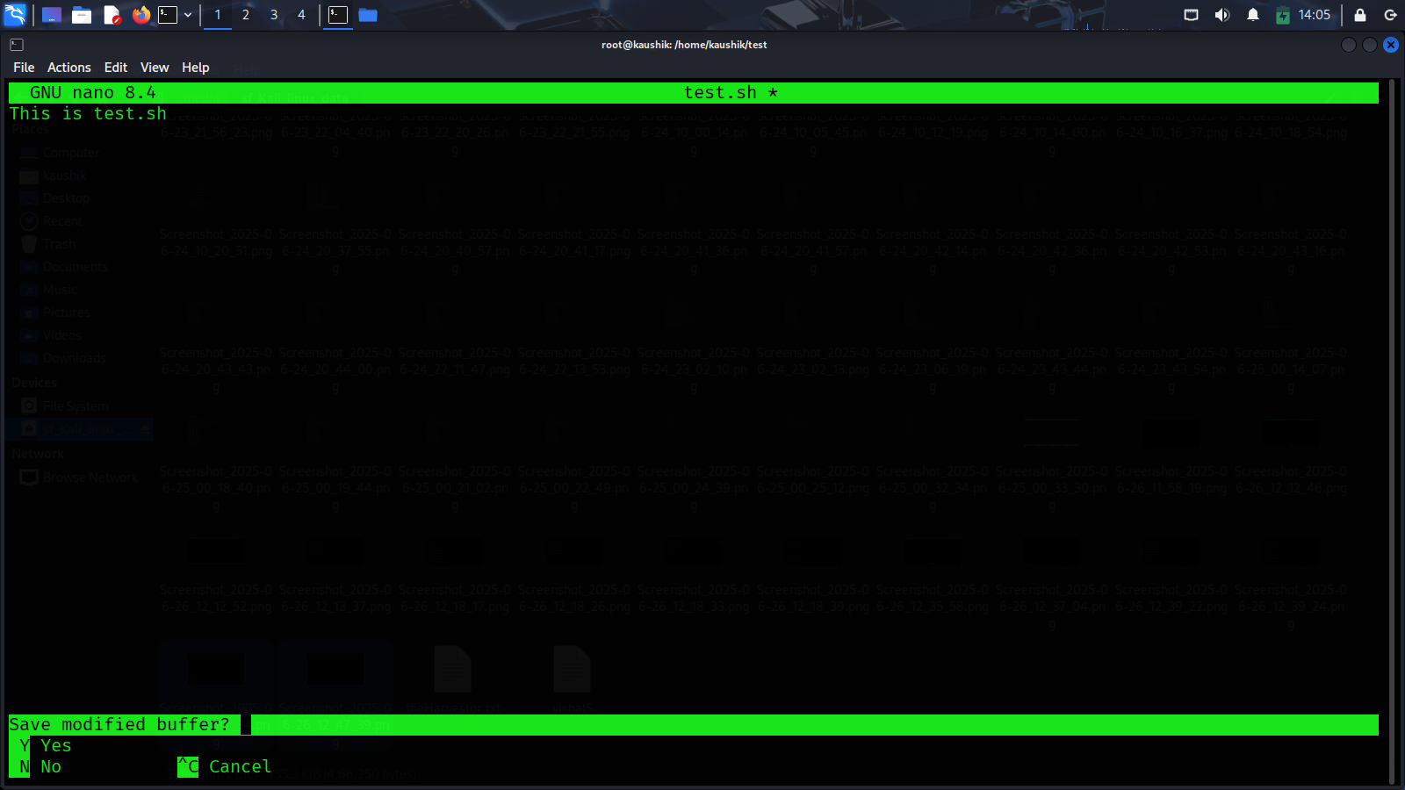

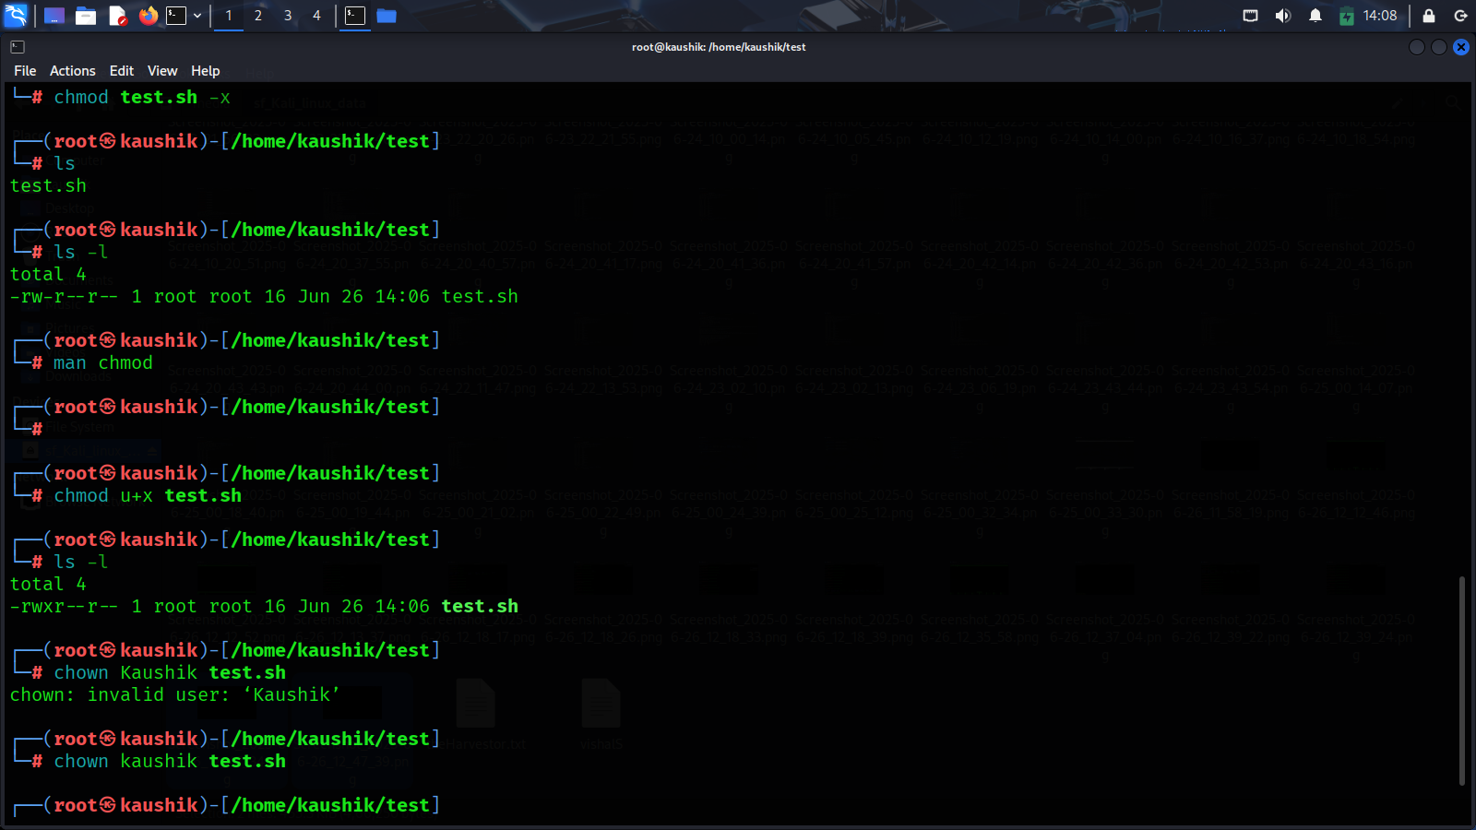

Page 4: Users and Groups

Task 1: Users and Group Management

- Commands: adduser, usermod, passwd, groups, id, su, sudo

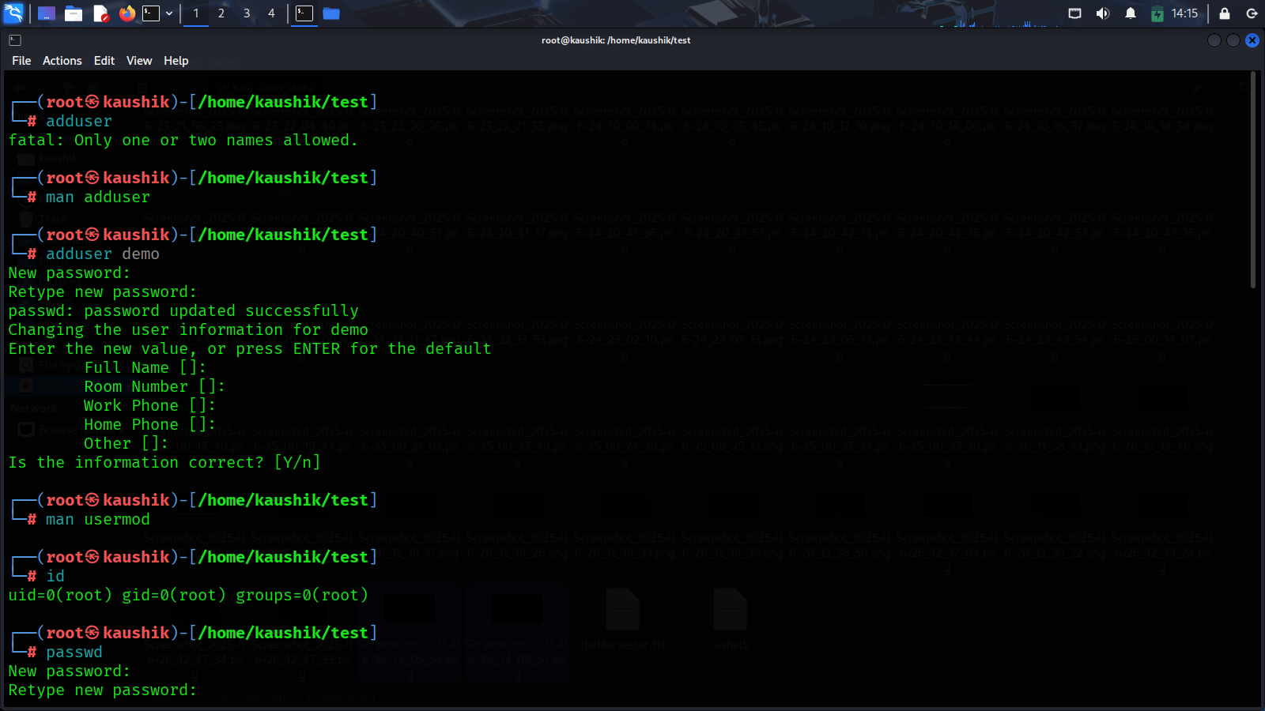

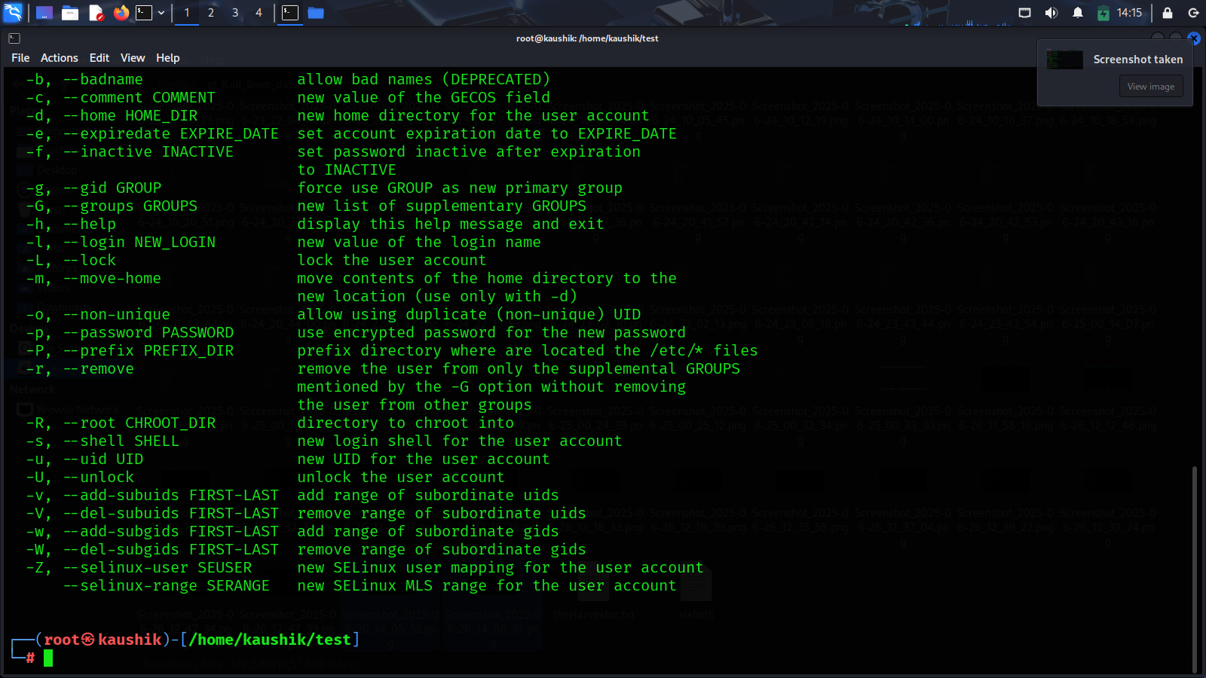

Task 2: Exercises

- Create a user called intern1 and a group called interns.

- Add intern1 to interns group. - Set a password for the user.

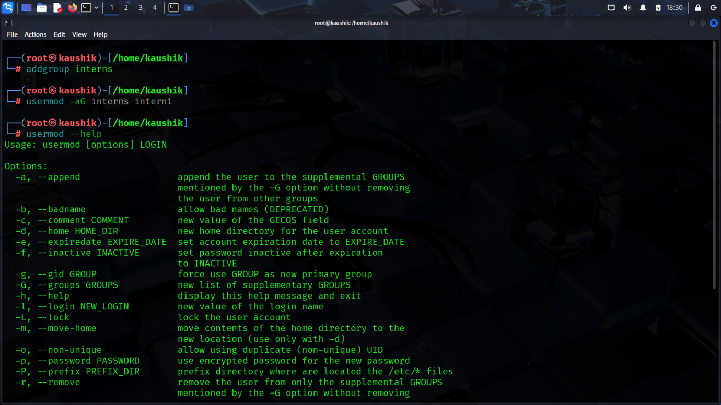

Page 5: Package Management

Task 1: Package Installations

- Difference between apt, yum, and dnf.

- Commands: sudo apt update && sudo apt upgrade, sudo apt install

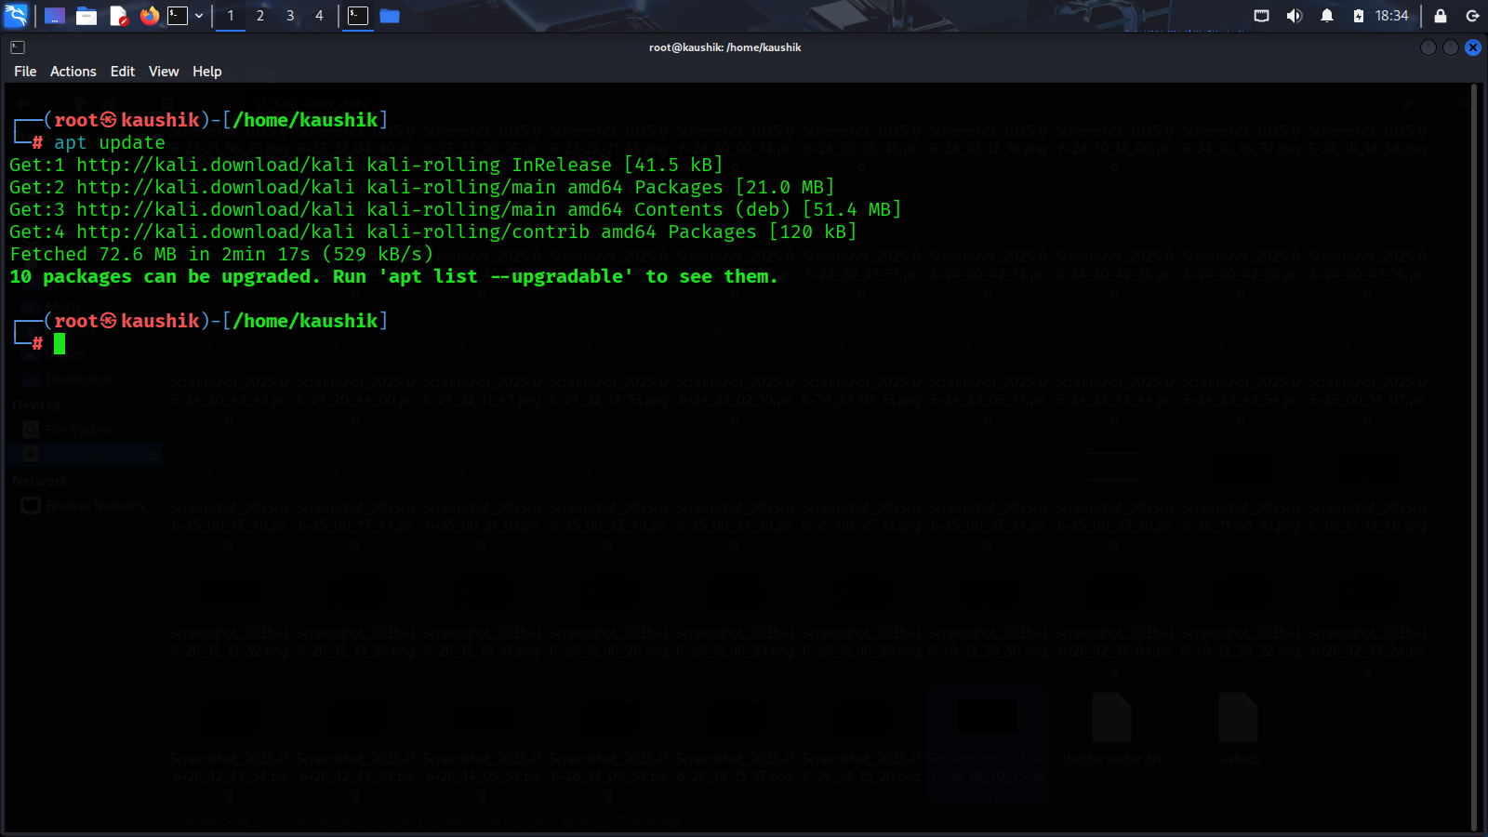

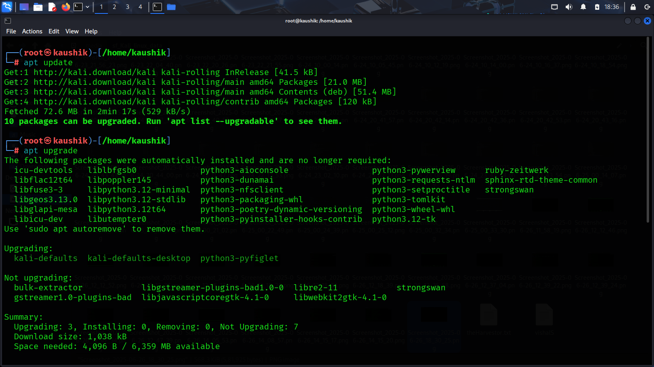

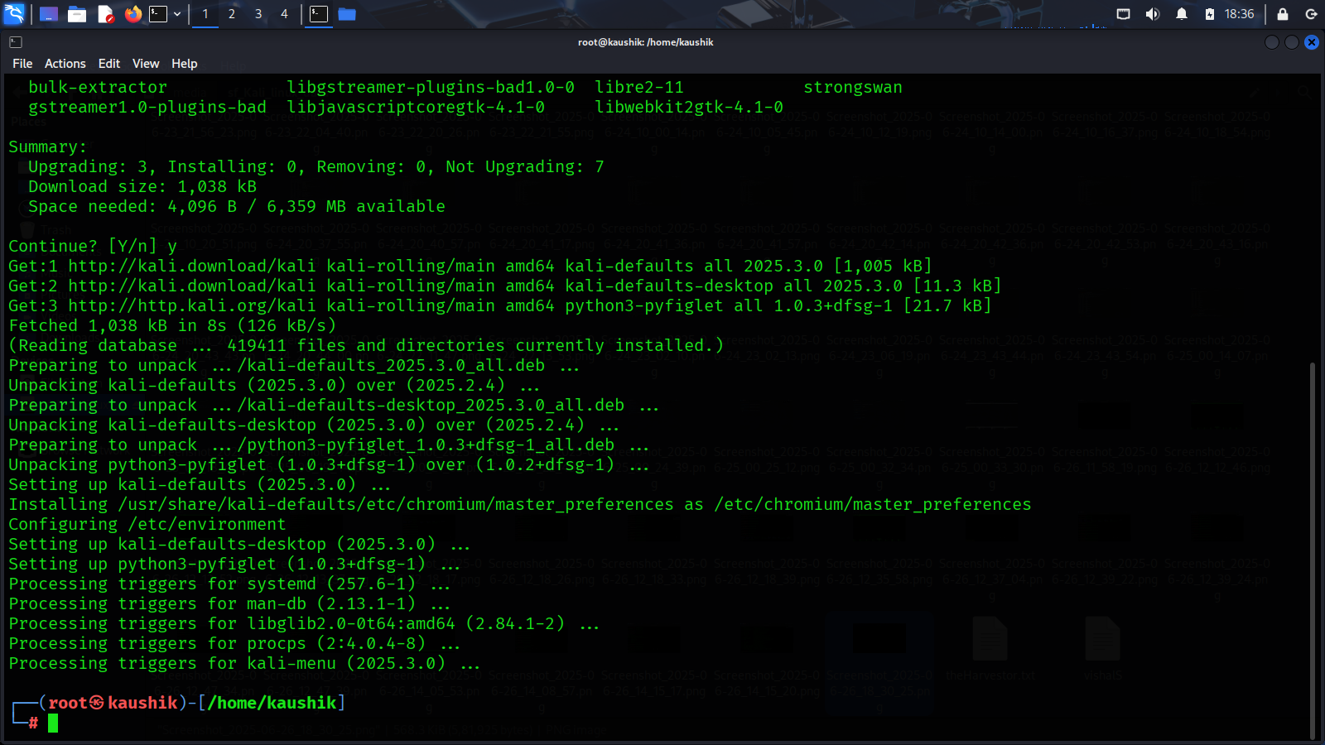

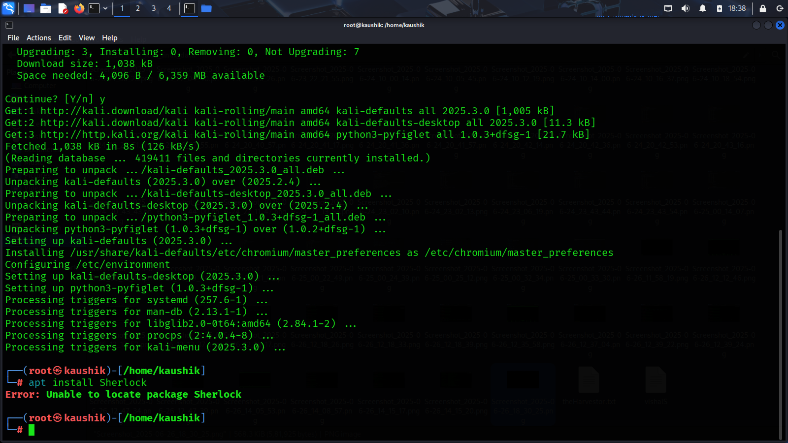

Task 2: Exercises

- Install curl, git, and tree on your system.

- Remove tree afterward using a package manager.

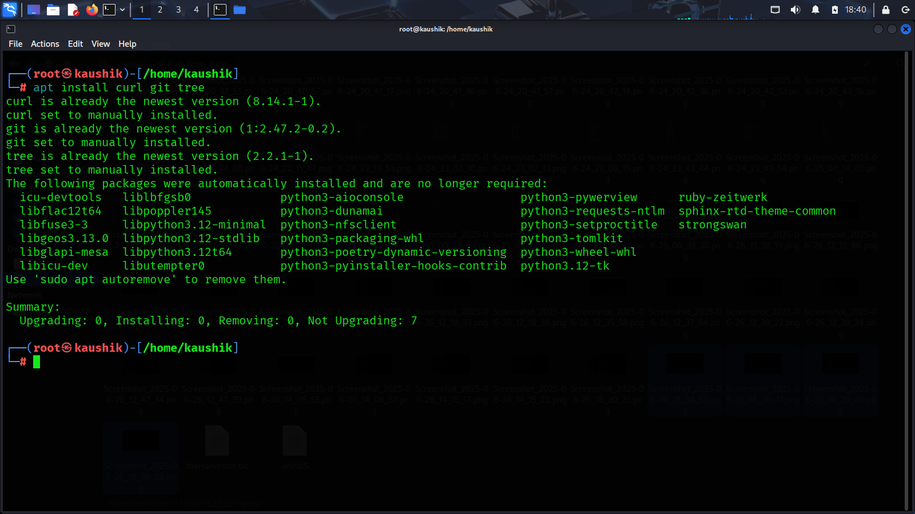

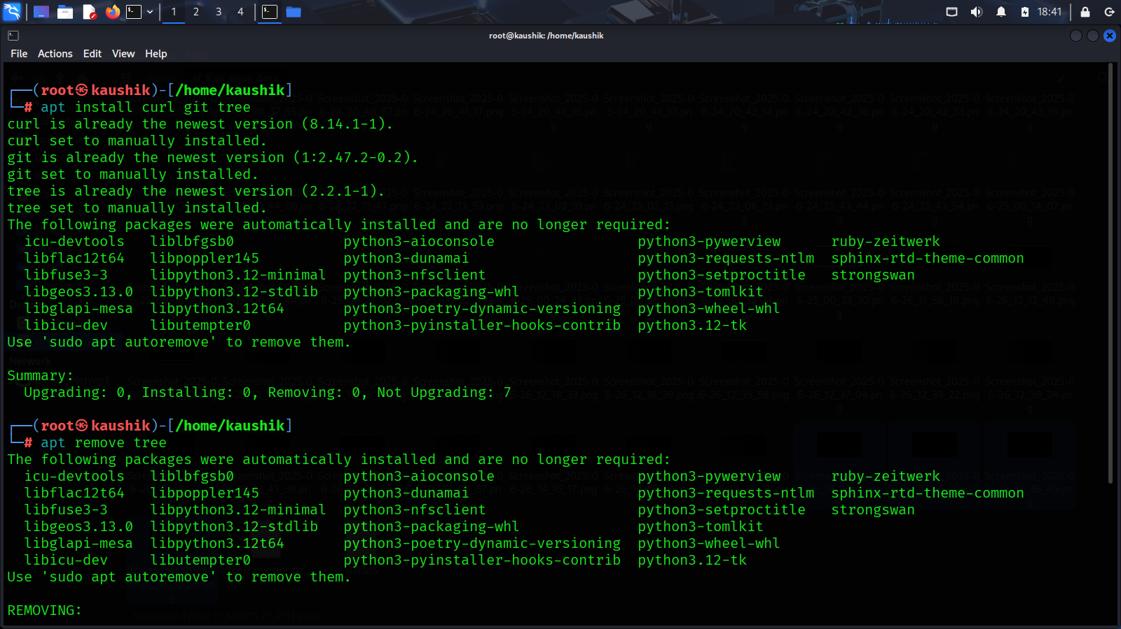

Page 6: File Searching and Redirection

Task 1: Search and Filters

- Commands: find, grep, locate, head, tail, sort, wc

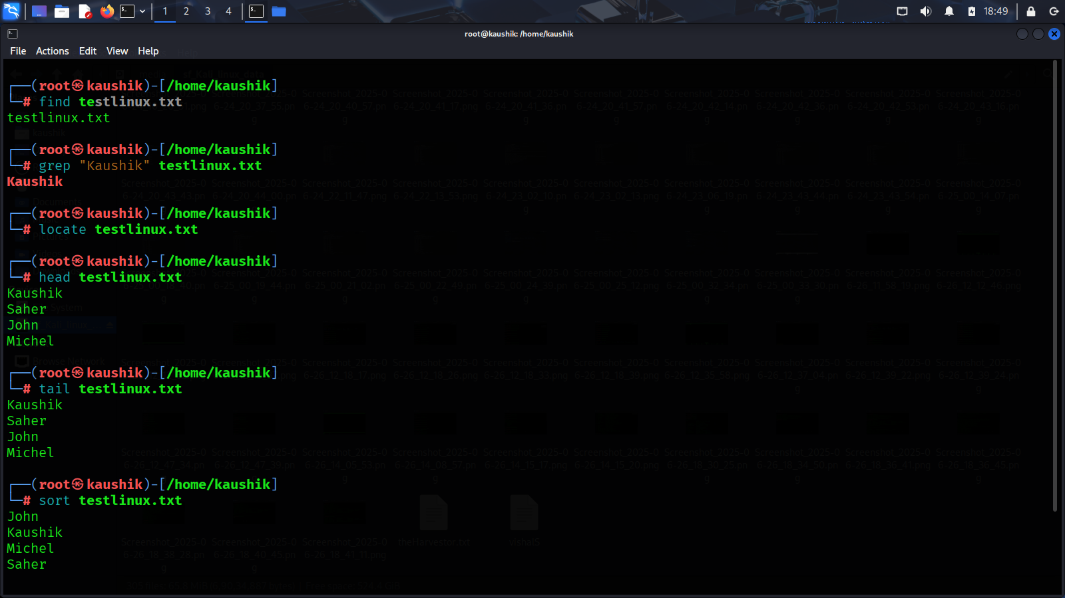

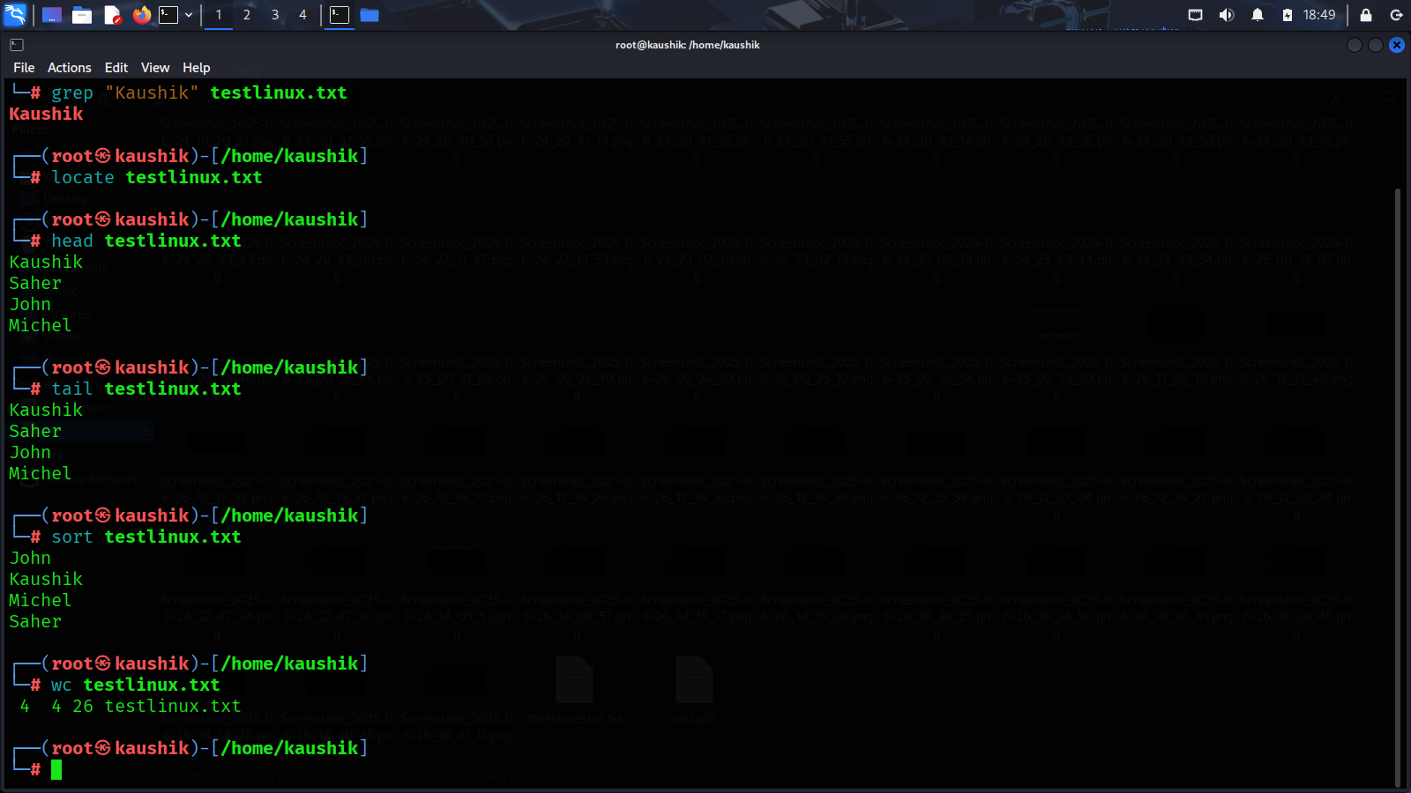

Task 2: Redirection

- Usage of >, >>, <, |

Exercise:

- Create a file with multiple lines.

- Use grep to find a keyword.

- Pipe output of ls -l into grep and filter .sh files.

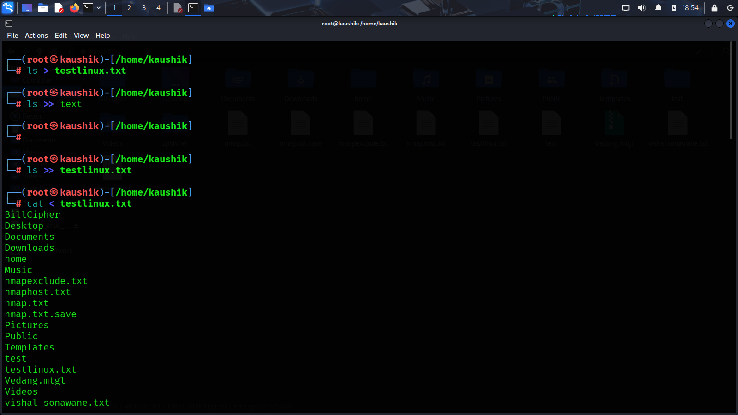

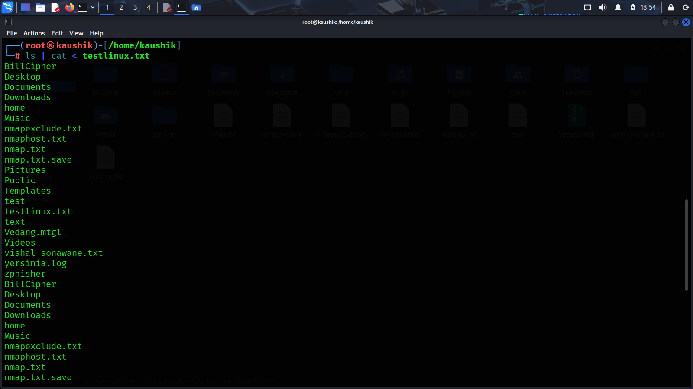

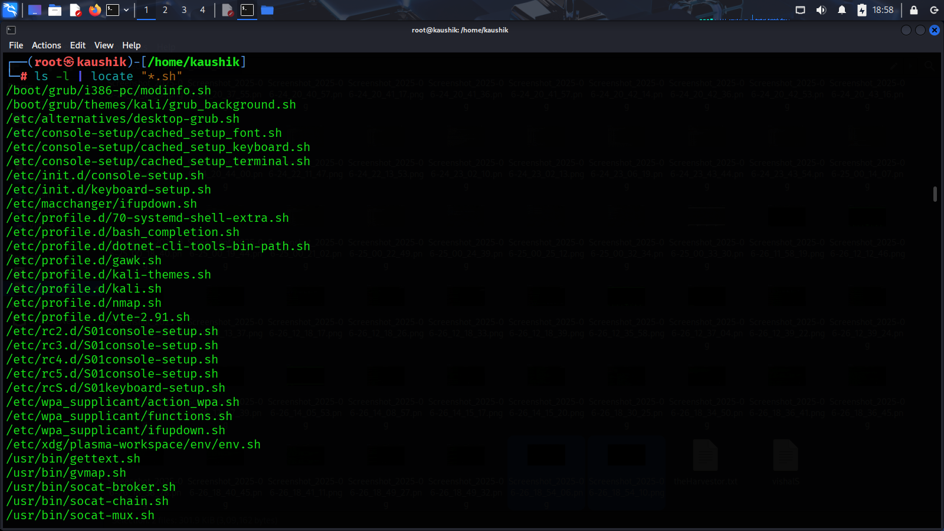

Page 7: Bash Scripting Basics

Task 1: Write your first script

- Components: Shebang (#!/bin/bash), Variables, If-Else, Loops

Exercise:

- Create a script greet.sh that accepts a name and prints "Hello, $name".

- Write a script that prints numbers 1 to 10 using a for loop.

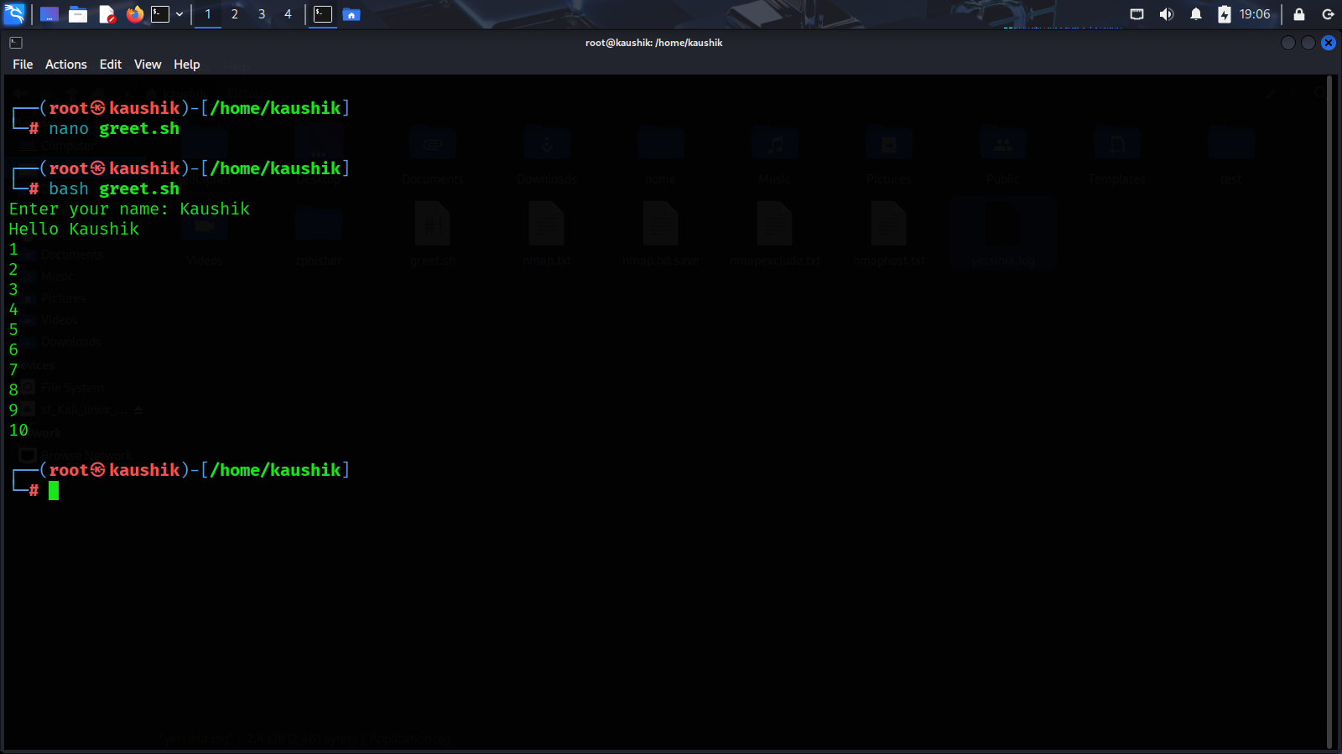

Page 8: System Monitoring & Logs

Task 1: Monitoring

- Commands: top, htop, ps, df -h, du -sh, free -m

Task 2:

Logs - Log location: /var/log/ - View logs using tail, less, cat

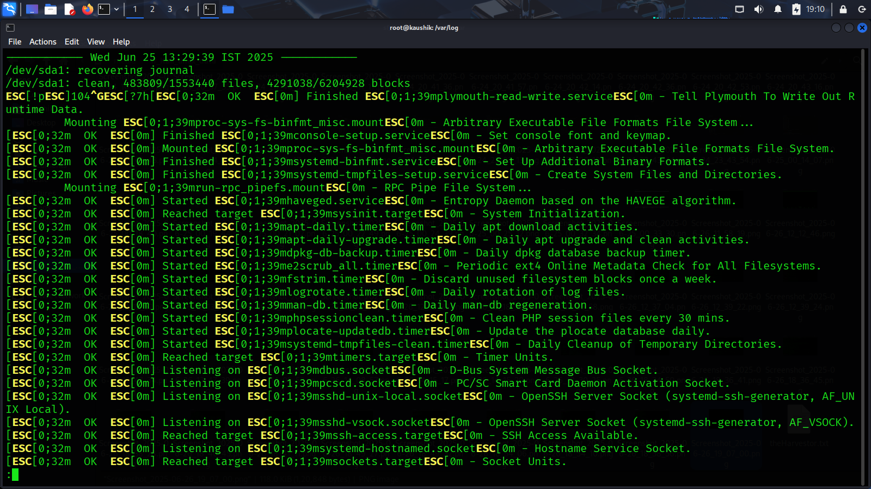

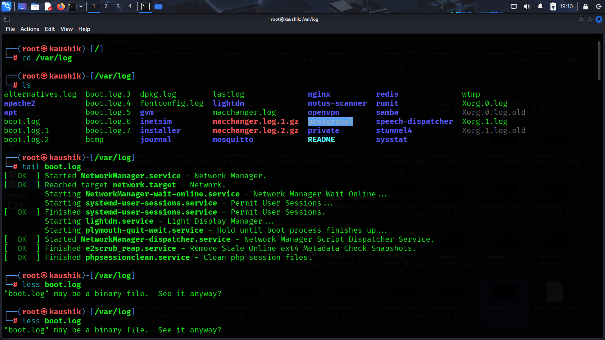

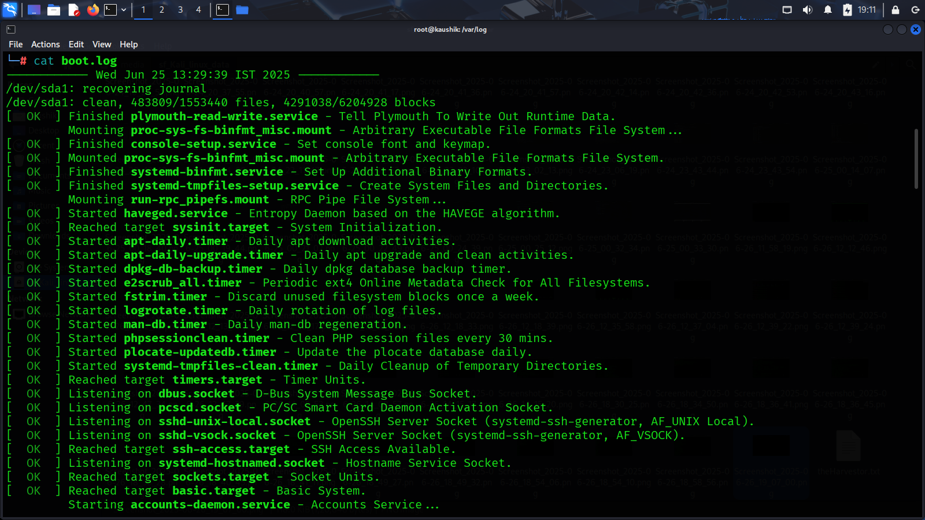

Exercise: - Monitor memory and CPU usage using top.

- View last 10 lines of the syslog.

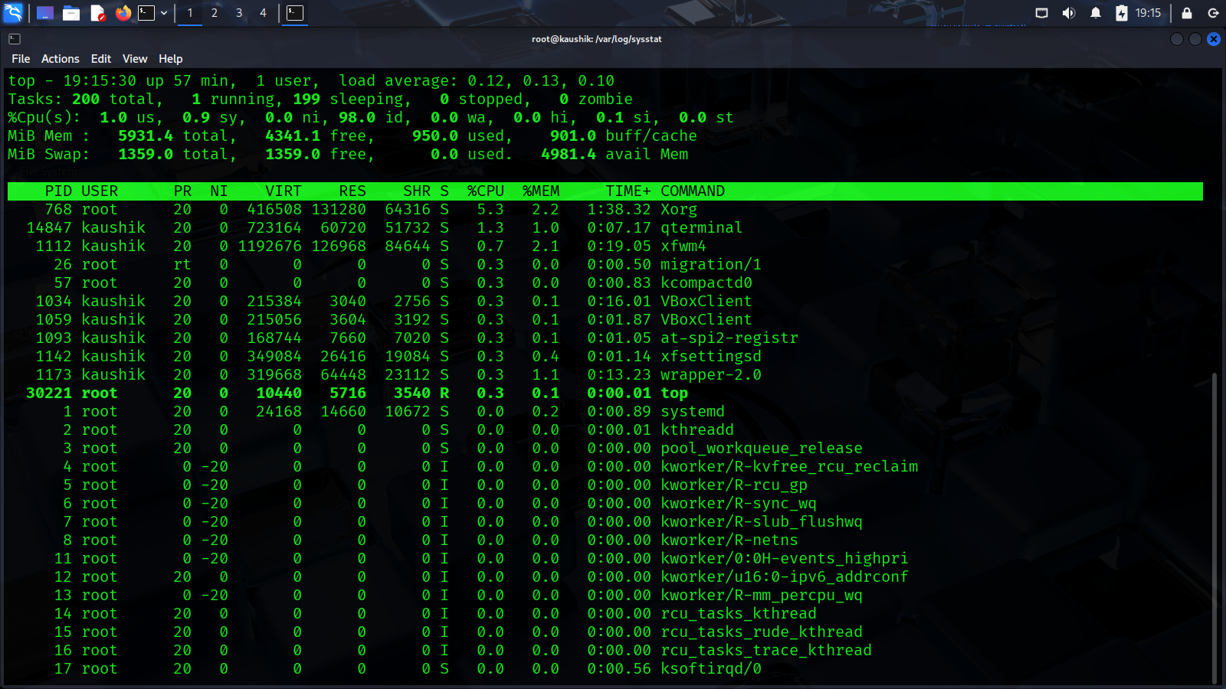

Page 9: Networking in Linux

Task 1: Networking Commands

- Commands: ifconfig, ip a, ping, netstat, curl, wget, hostname, ssh

Task 2: Exercises

- Ping google.com and capture output.

- Use curl to fetch HTML of a website.

- SSH into a remote system (if available).

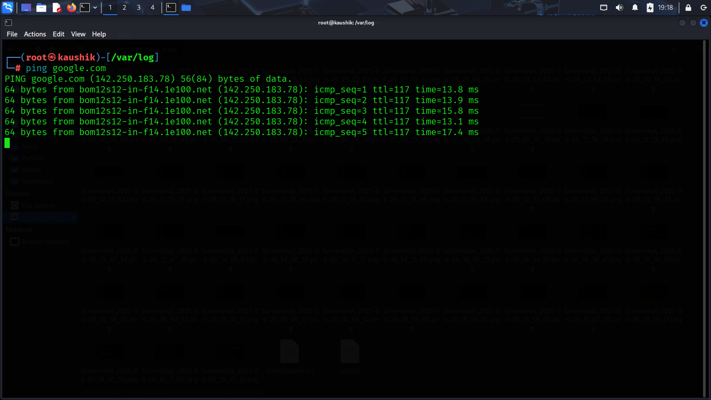

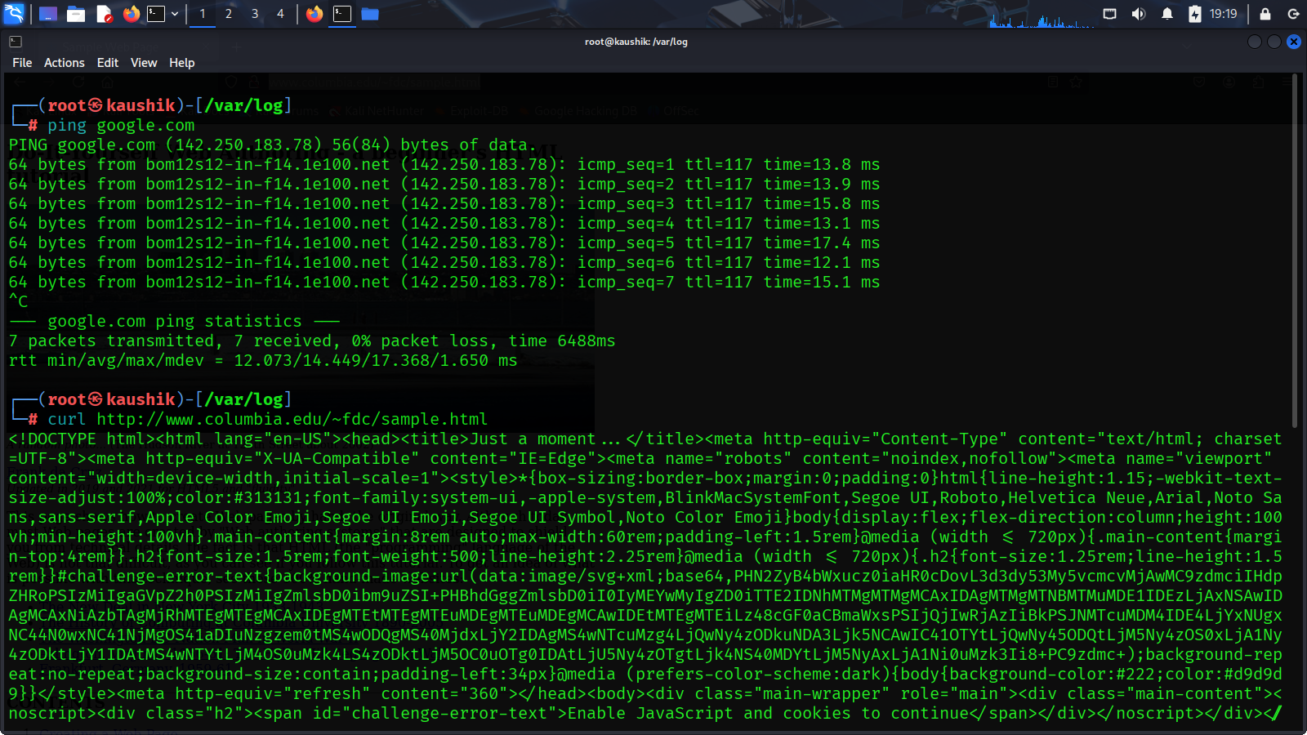

Page 10: Final Challenge (Capstone)

Task 1: Capstone Exercise

Combine your knowledge in a small real-world task.

- Create a bash script that:

1. Checks if curl is installed.

2. If not, installs it.

3. Fetches data from https://api.github.com and saves to github.txt

4. Logs the operation in a file called operation.log with timestamps.

